Practice Lab 08

Inner Joins

- Write a Query that retrieves each employee’s extension and first name with the phone which he uses, using inner join with customers.

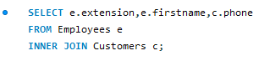

- Write SQL query that shows those customers names and address whose payment amount is more than 30000 using inner join.
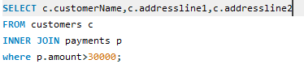

- Write an SQL query that retrieves product Vendor and Product names with the Ordered quantity less than 20.
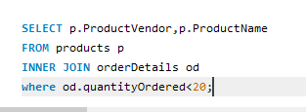

- Write Inner Join SQL query that retrieves employee’s names with job titles whose offices located in Sydney.
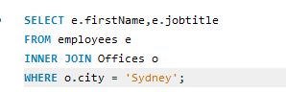

- Write an inner Join SQL query that retrieves customer’s names whose payment amount lies between 60000 and 70000.
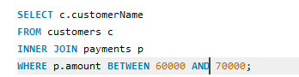

- Write SQL query that retrieves names of those employees whose offices located in cities having name starts with ‘S’.
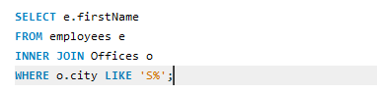

- Write a SQL query that retrieves the complete record of all the employees whose territory is Japan.
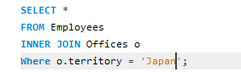

- Write a query that retrieves the status and comments of customers with their name whose shipped date is in year 2003.
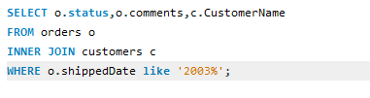
- Write a query that display text description of those products whose name contains “Harley” .
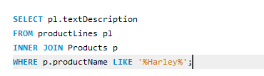
- Write SQL query to retrieve the order numbers of those customers whose contact first name starts with A and the quantity ordered is greater than 50.
